**COLLEGE WEBSITE**

**MINI PROJECT REPORT**

**BACHELOR OF TECHNOLOGY**

Computer Science and Engineering

**SUBMITTED BY**

Aabish Khan (2105050100001)

Aanya Shukla (2105050100002)

Ankush Kr. Verma (2105050100008)

2022-23



**UNDER THE SUPERVISION OF**

Ms. Renu Chaurasia

**DEPARTMENT OF COMPUTER SCIENCE & ENGINEERING**

**ALLENHOUSE INSTITUTE OF TECHNOLOGY KANPUR**

**ABSTRACT**

College website presents the information about the college .This website provides all the information regarding the admission, placements, infrastructure etc. This is website is designed to gather and provide information about college easily. The special feature in this website is given that you can chat directly to the college for queries. It contains all the clips of glorious moments and events organized in the college. Website is the easiest and fastest platform to visit any institute virtually.

**CERTIFICATE**

This is to certify that the project report (KCS354) entitled **“COLLEGE WEBSITE”** done by **Aabish khan (2105050100001) ,** **Aanya Shukla (2105050100002) , Ankush kr. Verma** **(2105050100008),** is an authentic work carried out by them at **Allen house Institute of** **Technology** under the guidance **of Ms. Renu Chaurasia.** The matter embodied in this project work has not been submitted earlier for the award of any degree or diploma to the best of my knowledge and belief. Certified that this is a bonafide record of the project work titled.

**Ms. Renu Chaurasia Dr. Sudhir Kr Singh**

Project Guide Head of Department

**TABLE OF CONTENT**

1. Introduction of Project 5
2. Objective 6
3. Hardware & Software Specification 7
4. Design 8
5. Coding 9-15
6. Screenshots 16-17
7. Conclusion and Future Scope 55
8. Bibliography 56

**INTRODUCTION OF PROJECT**

A **website** (also written as a **web site**) is a collection of web pages and related content that is identified by a common domain name and published on at least one web server. Websites are typically dedicated to a particular topic or purpose, such as news, education, commerce, entertainment or social networking. The higher education institutions play a vital role in development of society. The need to provide information for prospective students, current students, faculty and alumni. Powerful website for colleges and universities help you to increase enrollment and gain competitive edge. A website is the great way to share your newly gained knowledge and skills with people from all around the world. It allows student to look for jobs and placements and keep track on changing trend in the job market.

**OBJECTIVE**

College The need to provide information for prospective students, current students, faculty and alumni. Powerful website for colleges and universities help you to increase enrollment and gain competitive edge. A website is the great way to share your newly gained knowledge and skills with people from all around the world. It allows student to look for jobs and placements and keep track on changing trend in the job market.

**HARDWARE AND SOFTWARE SPECIFICATION**

**Hardware Requirements**

1. Intel core i5 10th generation is used as a processor because it is fast than other processors and provide reliability and stability.
2. Ram 8gb is used as it will provide fast reading and writing capabilities and will in turn support in processing.

**Software Requirements**

1. **Operating system-** Windows 10 is used as the operating system as it is reliable and supports more features and is more user friendly.
2. **Development tools and Programming languages-** HTML is used to make the framework of the website CSS along with JavaScript for styling work .

**Technology used in Project:**

The whole project is divided into two parts the frontend and back end.

1. **Front end:** The front end is designed using HTML, CSS, JavaScript.
2. **Back end:** The back end contains a server named Netlify.

**DESIGN**

**Module Description**

There are essentially two modules of this software:

**Admin module**: Admin will have complete control over the system. Admin has permissions to update, delete or modify any existing features and make new changes. Admin id directly integrated with the query raising system where all the queries raised on the website are directly available on his mail.

**Normal Users:** The normal users enjoy only limited privileges. They can view the website and collect information regarding the college. Even the users can deposit their fees through the website. And, with the option to visit the college ERP.

**CODING**

<!DOCTYPE html>

<html lang="en">

<head>

  <meta charset="UTF-8">

  <meta http-equiv="X-UA-Compatible" content="IE=edge">

  <meta name="viewport" content="width=device-width, initial-scale=1.0">

  <title>Nav bar</title>

  <link rel="stylesheet" href="navbar.css">

  <link rel="stylesheet" href="https://cdnjs.cloudflare.com/ajax/libs/font-awesome/6.2.1/css/all.min.css">

  <link rel="stylesheet" href="https://cdn.jsdelivr.net/npm/swiper@8/swiper-bundle.min.css" />

  <link rel="style sheet" href="https://cdn.jsdelivr.net/npm/bootstrap@5.2.3/dist/css/bootstrap.min.css">

  <link rel="stylesheet" href="https://cdn.jsdelivr.net/npm/@fortawesome/fontawesome-free@6.2.1/css/fontawesome.min.css">

  <link rel="stylesheet" href="https://fonts.googleapis.com/css?family=Sofia">

  <script src="https://code.jquery.com/jquery-1.12.4.js"></script>

  <script src="https://kit.fontawesome.com/a076d05399.js"></script>

  <script src="https://cdnjs.cloudflare.com/ajax/libs/jquery/3.6.2/jquery.min.js"></script>

  <script src="https://cdnjs.cloudflare.com/ajax/libs/waypoints/4.0.1/jquery.waypoints.min.js"></script>

  <script src="https://cdnjs.cloudflare.com/ajax/libs/Counter-Up/1.0.0/jquery.counterup.min.js"></script>

  <script src="https://kit.fontawesome.com/6965d4a068.js" crossorigin="anonymous"></script>

</head>

<body>

  <header>

    <a href="#" class="brand"><img src="Allen_Logo.png"></a>

    <div class="menu">

      <div class="btn">

        <i class="fas fa-times close-btn"></i>

      </div>

      <a href="aboutus.html">About Us</a>

      <a href="academics.html">Academics</a>

      <a href="Admission.html">Admission</a>

      <a href="lifeatallem.html">Life at allen house</a>

      <a href="contactus.html">Contact us</a>

    </div>

    <div class="btn">

      <i class="fas fa-bars menu-btn"></i>

    </div>

  </header>

  <section class="section-main">

    <div class="container-slider">

      <div class="loader">

        <h1>Allen house Institute of Technology</h1>

        </div>

      <div class="swiper">

        <!-- Additional required wrapper -->

        <div class="swiper-wrapper">

          <!-- Slides -->

          <div class="swiper-slide"><img src="images/sliderimage1.jpeg" height="700">

          </div>

          <div class="swiper-slide"><img src="images/sliderimage2.jpeg" height="700"></div>

          <div class="swiper-slide"><img src="images/sliderimage3.jpeg" height="700"></div>

          <div class="swiper-slide"><img src="images/sliderimage4.jpeg" height="700"></div>

          <div class="swiper-slide"><img src="images/sliderimage5.jpeg"height="700"></div>

        </div>

        <!-- If we need pagination -->

        <div class="swiper-pagination"></div>

        <!-- If we need navigation buttons -->

        <div class="swiper-button-prev"></div>

        <div class="swiper-button-next"></div>

      </div>

    </div>

  </section>

  <div class="popup">

    <div class="close"><img src="/images/close.png" height="20x"></div>

    <img src="/images/Screenshot (150).png" height="650px">

  </div>

  <script>

    const popup = document.querySelector('.popup');

    const close = document.querySelector('.close');

    window.onload = function () {

      setTimeout(function () {

        popup.style.display = "block"

      }, 2000)

    }

    close.addEventListener('click', () => { popup.style.display = "none"; })

  </script>

  <script type="text/javascript">

    window.addEventListener("scroll", function () {

      var header = document.querySelector("header");

      header.classList.toggle('sticky', window.scrollY > 0);

    });

  </script>

  <script src="https://cdn.jsdelivr.net/npm/swiper@8/swiper-bundle.min.js"></script>

  <script>

    const swiper = new Swiper('.swiper', {

      autoplay: {

        delay: 2000,

        disableOnInteraction: false,

      },

      // Optional parameters

      loop: true,

      // If we need pagination

      pagination: {

        el: '.swiper-pagination',

        clickable: true,

      },

      // Navigation arrows

      navigation: {

        nextEl: '.swiper-button-next',

        prevEl: '.swiper-button-prev',

      },

    });

  </script>

  <!--section 2 for abut -->

  <section class="section-about">

    <div class="video">

      <iframe  src="https://www.youtube.com/embed/FslFvk4BbE4" title="YouTube video player"

        frameborder="0" allow="accelerometer; autoplay; clipboard-write; encrypted-media; gyroscope; picture-in-picture"

        allowfullscreen></iframe>

    </div>

    <div class="text">

      <h1>About the Institute</h1>

      <pre>

Allen house Group of Institutions, established in the yea

r 2009, offers graduate and postgraduate courses in B.Tech.,

BBA, BCA, Polytechnic, and MBA. Allen house Colleges Campus

houses three Institutes, Allen house Institute of Technology

Allen house Business School & Allen house Institute of

Management. It is located at Rooma, Kanpur spread over a

sprawling green campus. It has been awarded as the Most

Outstanding Engineering& Management College in India. It is

also ranked as the 4th Best Private Engineering Institute in

Uttar Pradesh and as the 4th Top Emerging BBA Institute in

India. Allen house Colleges has the best infra structure and

offers top quality education with an exclusive overall

development of students.

</pre>

    </div>

  </section>

  <!--section 3 for videos-->

  <section class="section-videos">

    <div class="top">

      Watch the videos to know more...

    </div>

    <div class="Aboutvideos">

      <iframe  src="https://www.youtube.com/embed/I9yyFSZe64Y" title="YouTube video player"

        frameborder="0" allow="accelerometer; autoplay; clipboard-write; encrypted-media; gyroscope; picture-in-picture"

        allowfullscreen></iframe>

      <iframe   src="https://www.youtube.com/embed/UhZR29N677U" title="YouTube video player"

        frameborder="0" allow="accelerometer; autoplay; clipboard-write; encrypted-media; gyroscope; picture-in-picture"

        allowfullscreen></iframe>

      <iframe   src="https://www.youtube.com/embed/oyca2mfxK-M" title="YouTube video player"

        frameborder="0" allow="accelerometer; autoplay; clipboard-write; encrypted-media; gyroscope; picture-in-picture"

        allowfullscreen></iframe>  </div>

  </section>

  <!--section 4 for counter-->

  <div class="counter-up">

    <div class="content">

        <div class="box">

          <div class="icon"><i class="fa-solid fa-building-columns"></i></div>

          <div class="counter">724</div>

          <div class="text">Companies Visited</div>

        </div>

        <div class="box">

          <div class="icon"><i class="fa-solid fa-graduation-cap"></i></div>

          <div class="counter">508</div>

          <div class="text">Student Placed</div>

        </div>

        <div class="box">

          <div class="icon"><i class="fa fa-users"></i></div>

          <div class="counter">724</div>

          <div class="text">Community</div>

        </div>

        <div class="box">

          <div class="icon"><i class="fa fa-history"></i></div>

          <div class="counter">724</div>

          <div class="text">Total Student</div>

        </div>

      </div>

</div>

<script>

    $(document).ready(function () {

        $(".counter").counterUp({

            delay: 10,

            time: 1200

        });

    });

</script>

  <!--section 5 for important links-->

  <h2>Important Links</h2>

  <section class="links">

    <div class="link">

    <div class="item1"><a href="https://erp.allenhousecolleges.com/">Allen House ERP</a></div>

    <div class="item1"><a href="https://www.elogisol.com/elogipay/">Pay Fee</a></div>

    <div class="item1"><a href="https://allenhouse.ac.in/alumni-registration/">Alumni Registration</a></div>

  </div>

  </section>

  <!--section 6 for -->

  <section class="more">

    <div class="pros">

      <div class="item">AIT Prospectus</div>

      <div class="item">ABS Prospectus</div>

      <div class="item-2">

        <iframe src="pdf.pdf"></iframe></div>

      <div class="item-3">

       <iframe src="pdf2.pdf"></iframe></div>

    </div>

</div>

  </section>

  <footer class="footer">

    <div class="container">

        <div class="row">

            <div class="footer-col">

                <h4>Academics <div class='underline'><span></span></h4>

                <ul>

                    <li><a href="https://allenhouse.ac.in/mba/">MBA</a></li>

                    <li><a href="https://allenhouse.ac.in/bca/">BCA </a></li>

                    <li><a href="https://allenhouse.ac.in/bba/">BBA</a></li>

                    <li><a href="https://allenhouse.ac.in/b.tech/">B.Tech</a></li>

                    <li><a href="https://allenhouse.ac.in/diploma/">Diploma</a></li>

                    <li><a href="https://allenhouse.ac.in/applied-science-humanities/">Applied Human & Science</a></li>

                </ul>

            </div>

            <div class="footer-col">

                <h4>Facilites <div class='underline'><span></span></h4>

                <ul>

                    <li><a href="/foter/central_lib.html">Central Library</a></li>

                    <li><a href="/foter/computer_centre.html">Computer Centre</a></li>

                    <li><a href="/foter/health_care.html">Health Care</a></li>

                    <li><a href="/foter/gymnasium.html">Gymnasium</a></li>

                    <li><a href="/foter/cafeteria.html">Cafeteria</a></li>

                    <li><a href="/foter/hostel.html">Hostel</a></li>

                </ul>

            </div>

            <div class="footer-col">

                <h4>Admissions <div class='underline'><span></span></h4>

                <ul>

                    <li><a href="https://allenhouse.ac.in/admission-inquiry-2022/">Apply Now</a></li>

                    <li><a href="https://allenhouse.ac.in/e-brochure/">Brochure</a></li>

                </ul>

            </div>

            <div class="footer-col">

                <h4>Follow us <div class='underline'><span></span></div>

                </h4>

                <div class="social-links">

                    <a href="https://www.facebook.com/AllenhouseGroupofInstitutions/"> <i

                            class="fa-brands fa-facebook-f"></i></a>

                    <a href="https://twitter.com/allen_college"> <i class="fa-brands fa-twitter"></i></a>

                    <a href="https://www.instagram.com/allenhousecollege/"> <i class="fa-brands fa-instagram"></i></a>

                    <a href="https://www.linkedin.com/in/allenhousecolleges/"> <i class="fa-brands fa-linkedin"></i></a>

                </div>

            </div>

        </div>

        <br><br>

    </div>

    <hr>

    <p class="copyright"> Allen house Group of Institutions © 2022 - All Right Reserved</p>

    <hr>

</footer>

</body>

</html>

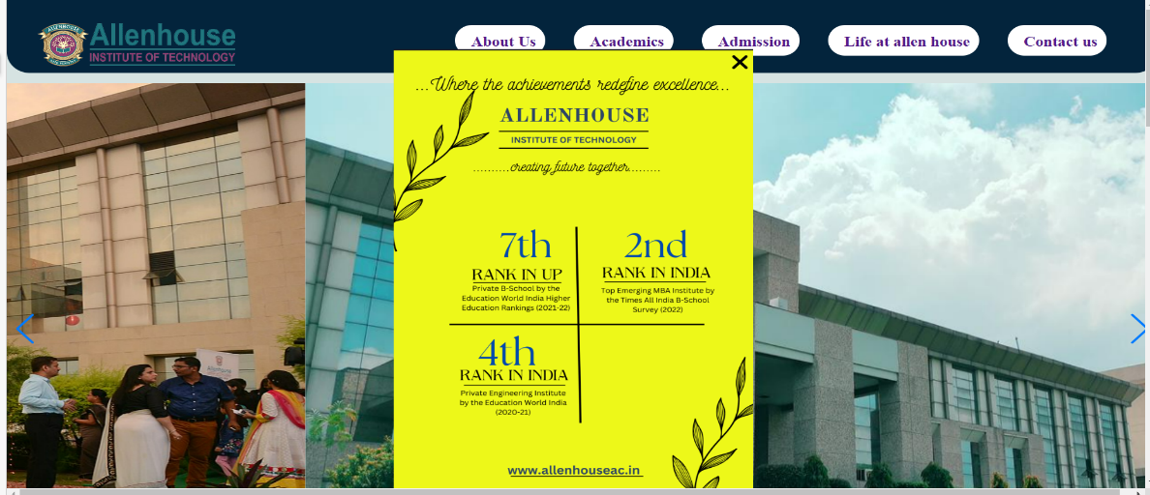 **SCREENSHOTS**

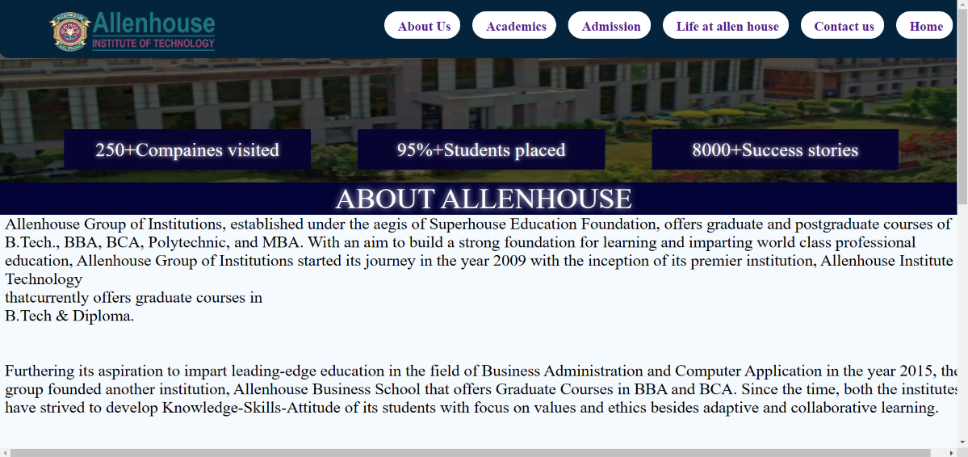

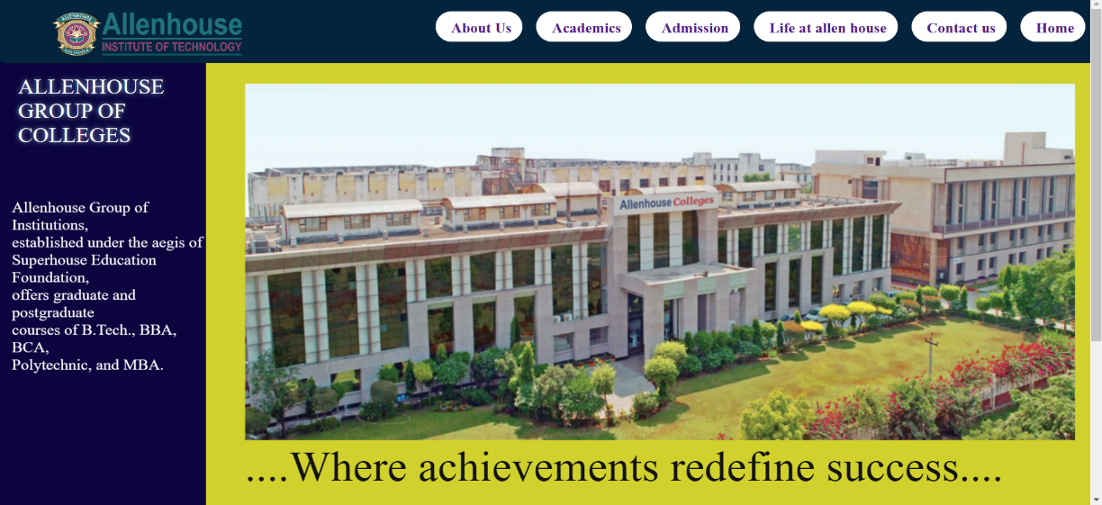

**SCREENSHOTS**

